**June 2023**

Dear Soon to be 4th Grade Parents,

Please read over the Summer Reading Assignment and expectations with your child. The Summer Reading Assignment is DUE **no later than** **September 15, 2023.**

The Summer Reading Assignment is for a First Quarter Report Card / ELA Grade. Please return to school with the book for some follow-up activities during the first few weeks of school.

Sincerely,

***Mrs. Fragale***

**________________________________________________________________________________**

We have read the information on the Summer Reading Assignment and have gone over the expectations.

**Student signature** _________________________________________________

**Parent signature** _________________________________________________

**Parent name (PRINTED)** _________________________________________________

**June 2023**

Dear Soon to be 4th Grade Parents,

We hope that you all have a fantastic summer vacation and enjoy God’s many blessings.

This letter is to inform you of the Summer 2023 Reading Assignment.

ALL 4th Grade students will be required to pick a book of their choice and over the summer. Attached to this letter, you will find the **activities** that your child is expected to complete while reading the book.

If you have any questions, please let us know. We are truly looking forward to another amazing year of growth, learning, and of course, fun!

Sincerely,

***Mrs. Fragale***



**Directions:** On lined paper, **write your first and last name on the top of the page** **and the name of the book and author. Please complete #1-5.**

1. Read **The book of your choice** and find **4** unfamiliar vocabulary words. Write the vocabulary word, rewrite the sentence that you found it in, write the page number, and write the definition of the word.
2. After reading **Chapter 1**, write one question that you would ask a classmate after reading that chapter.
3. Write about one (1) self to text connection that you can think of after completing the book.
4. Draw a picture that comes to your mind after reading **your favorite chapter in this book**. Be sure to tell what chapter this is and why it is your favorite chapter.
5. Write if you would recommend this book to a friend or not and explain your answer.

**Sneak Peek:** The following directions below will be for you to complete when we return to school in September. The activity below is our follow- up activity once we are back in school.

**ORAL PRESENTATION – DIRECTIONS**

Pick one (1) option from below as to how you would like to present. You will give an oral presentation on your Summer Reading Book to the class. Your task will be to tell the class all about your favorite part or parts of the book. Your oral presentation will be graded on the attached rubric. Have fun!

**OPTIONS:**

* Create a song about your favorite part.
* Act out your favorite part.
* Make a poster about your favorite part.
* Do a comic strip about your favorite part.
* Give a speech about your favorite part.
* Other

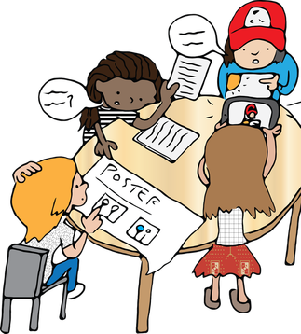**Start Date: ________________________**

**Due Date: ________________________**